Cloud Computing
Student’s Name
Institutional Affiliation
Course Name & Number
Instructor”s Name
Due Date

Cloud Computing
- The Emergence Of Cloud Computing
Cloud computing has been in existence since the early 2000s, although the origin can be traced to around the 1950s, a period in which mainframes could not be bought but only be rent by various organizations (Namasudra, 2018). Companies just bought one or two computers and implemented a time-sharing theory to ensure their full utilization. The theory could allow several users to access the same computer from other connected stations.
In 1955, John MacCarthy, who was the man behind artificial intelligence, came up with a mechanism that allowed computing time to be shared among several computer users (Namasudra, 2018). His invention formed one of the most outstanding achievements because maximizing computing time would be cheap, particularly to companies looking to invest in technology. With MacCarthy’s development, computing would now be available to both the bigger companies and the smaller companies that could not afford to perchance the mainframes (Namasudra, 2018).
The biggest development in cloud computing happened in the 1960s (Namasudra, 2018). The system of interconnected computers, a concept initially developed by J.C.R Licklider, were utilized by Bob Taylor and Larry Roberts to develop the Advanced Research Projects Agency Network (ARPANET). With ARPANET, the predecessor to the internet, a network could be created in which digital sources could be transferred to other computers in other locations. There were so many technological developments in the 1970s through 1990s, including the invention of the Virtual Machine (VM) operating system by IBM (Namasudra, 2018). In the 1990s, various telecommunication organizations had begun offering their own Virtualized private networks (VPNs). By the mid-1990s, the pace of cloud computing was approaching its peak. Nevertheless, the idea of shared computing was still in existence, especially with the service providers, utility computing, and grid computing in the late 1990s and early 2000s (Namasudra, 2018). Cloud computing that provides software services then emerged with hyper-scale cloud providers such as Amazon Web Services.
- Service Within The Context Of Cloud Computing
Service refers to any services that the computing providers offer to the users who require them through the internet. Such services can be accessed in a remote cloud computing server and not an onsite server within the company's premises. The services are offered by cloud services providers who ensure that the resources and applications are made available easily, ensuring scalability and full management by the cloud service provider. Cloud providers also ensure information security, lowered costs, increased flexibility, and higher speeds (Varghese & Buyya, 2018). Examples of cloud computing services include software, process, infrastructure, storage, database, information, application, integration, security, management, testing, and platform services.
Components Of An IT Resource
Generally, an IT resource has five constituents: hardware, software, network, databases and data warehouses, and human resources and procedures. The hardware is the physical technology that includes the servers, data centers, PCs, routers, among other appliances that interact with computers (Sarikaya, 2017). The software component includes programs utilized in the web servers, content management systems, and operating systems. Network component allows for internal and external systems communications that involve the internet, firewalls, security, Wi-Fi, or other hardware such as cables and routers. Databases and warehouses form the places where data can be collected, stored, and retrieved. Databases contain all information resources of the originations. The human element refers to the individuals responsible for running the system, with instructions to interpret the databases' information (Sarikaya, 2017).
- Horizontal Scaling
Horizontal scaling refers to capacity improvement through the addition of more computers to the current infrastructure. With horizontal scaling, more resources are added to the system by increasing the number of machines in the network to ensure that processing and data storage strains are shared in multiple devices (Patil & Singh, 2013). Sharing means that the sequential pieces of logic are partitioned to allow simultaneous execution in several machines. The advantage of this scaling method is that it evades the problem of resource deficit. The user thus benefits from elasticity.
Examples include load balancing and the shared database. In load balancing, a load balancer distributes the users to instances. During upsurges in traffic, auto-scaling occurs for the addition of more instances. Shared databases involve many cloud instances. When a batch job is introduced, it is shared among the instances which coordinate with a cloud database to complete the task. Examples include Cassandra and MongoDB (Patil & Singh, 2013).
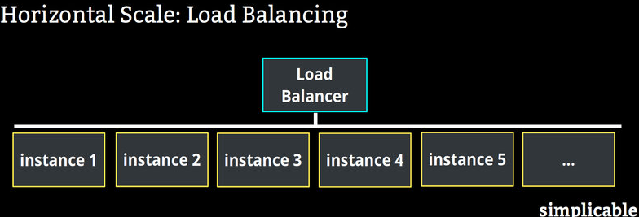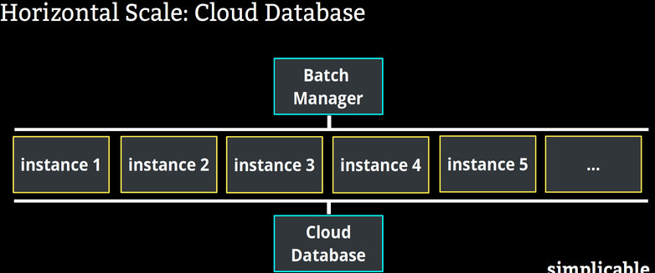
Vertical Scaling
The vertical scaling uses an approach of increasing computing resources in the infrastructure. More processing power is added to the already existing machine by adding higher capacity resources such as CPU, RAM, and discs to the server in demand (Patil & Singh, 2013). For these scaling methods, the original databases and application servers are retained. The logic also remains the same, only that the code is now run on machines with more extraordinary specifications. As compared to horizontal scaling, vertical scaling is restricted to machine capacity and hence more downtime.
Vertical scaling increases the processing capacities of individual servers to handles increasing traffic. Thus, to manage increasing traffic, a website infrastructure needs to be scaled up through the addition of higher capacity CPU processors, RAM, and storage disks. Examples are MySQL and Amazon RDS (Patil & Singh, 2013).
- Virtualization In Cloud Computing Environments
Virtualization in cloud computing means reproducing the servers' physical network, operating system, storage network, or network resources with a server's virtual platform to allow them to run on several machines simultaneously. Virtualization aims to transform traditional computing to allow efficient use of computer resources to make it more scalable, secure, responsive, and economical (Kumar & Kushwaha, 2018). There are three main types of virtualization: Server, network, and desktop virtualization. Server virtualization on which many operating systems are made to run on one physical server very efficiently. Network vitalization established a virtual network where applications run similarly as in the physical network but with more operational advantages. On the other hand, desktop virtualization ensures quick response changes in the workplace environment and opportunities, which allows for quick delivery of the virtualized desktops to other branches and outsourced workers (Kumar & Kushwaha, 2018).
Purpose Of A Virtualization Environment
Three layers within the virtualization environment facilitate the cloud computing function: the physical layer, the network, and the server and storage layer. According to Pal & Pattnaik (2013), a virtualization environment allows the user to configure computing power and storage systems. It is essential in establishing virtual computers that from the valuable constituents of cloud computing. It provides a virtual platform with a sophisticated IT infrastructure that ensures scalability in the delivery of services. A virtualization environment also provides a homogenous environment, standardized management infrastructure, lighter tasks, and single standard software architecture. Moreover, in cloud computing, a virtualization environment facilitates consolidation, more effortless development flexibility, migration and cloning, stability and security, and paravirtualization (Pal & Pattnaik, 2013).

Reference
Kumar, S., & Kushwaha, A. S. (2018, August). Virtualization Backbone of Cloud Computing-Analysis. In 2018 4th International Conference on Computing Sciences (ICCS) (pp. 35-39). IEEE.
Namasudra, S. (2018). Cloud computing: A new era. Journal of Fundamental and Applied Sciences, 10(2).
Pal, A. S., & Pattnaik, B. P. K. (2013). Classification of virtualization environment for cloud computing. Indian Journal of Science and Technology, 6(1), 3965-3971.
Patil, R., & Singh, R. (2013). Scaling in cloud computing. International Journal of Advance Research, IJOAR, 1, 21-27.
Sarikaya, R. (2017). The technology behind personal digital assistants: An overview of the system architecture and key components. IEEE Signal Processing Magazine, 34(1), 67-81.
Varghese, B., & Buyya, R. (2018). Next generation cloud computing: New trends and research directions. Future Generation Computer Systems, 79, 849-861.

